- Use your browser's developer tools to visit any page on Myntra and list the HTTP status code and two key response headers returned for the main document request.
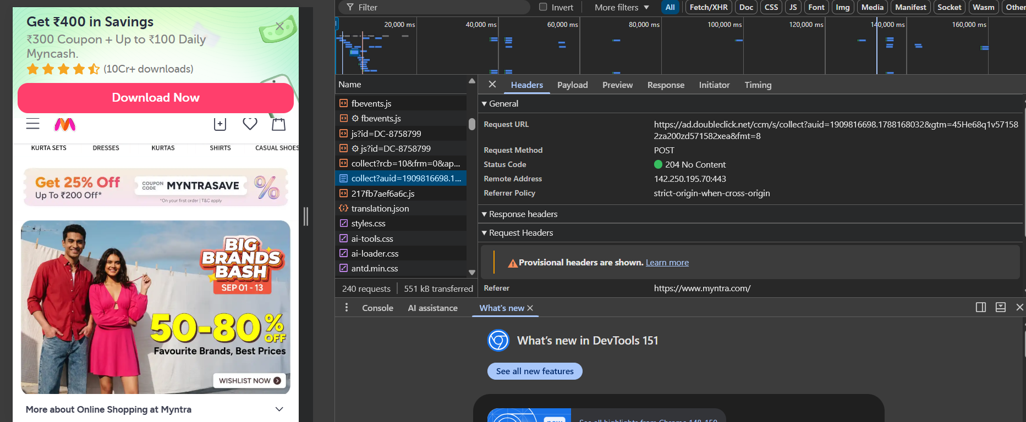
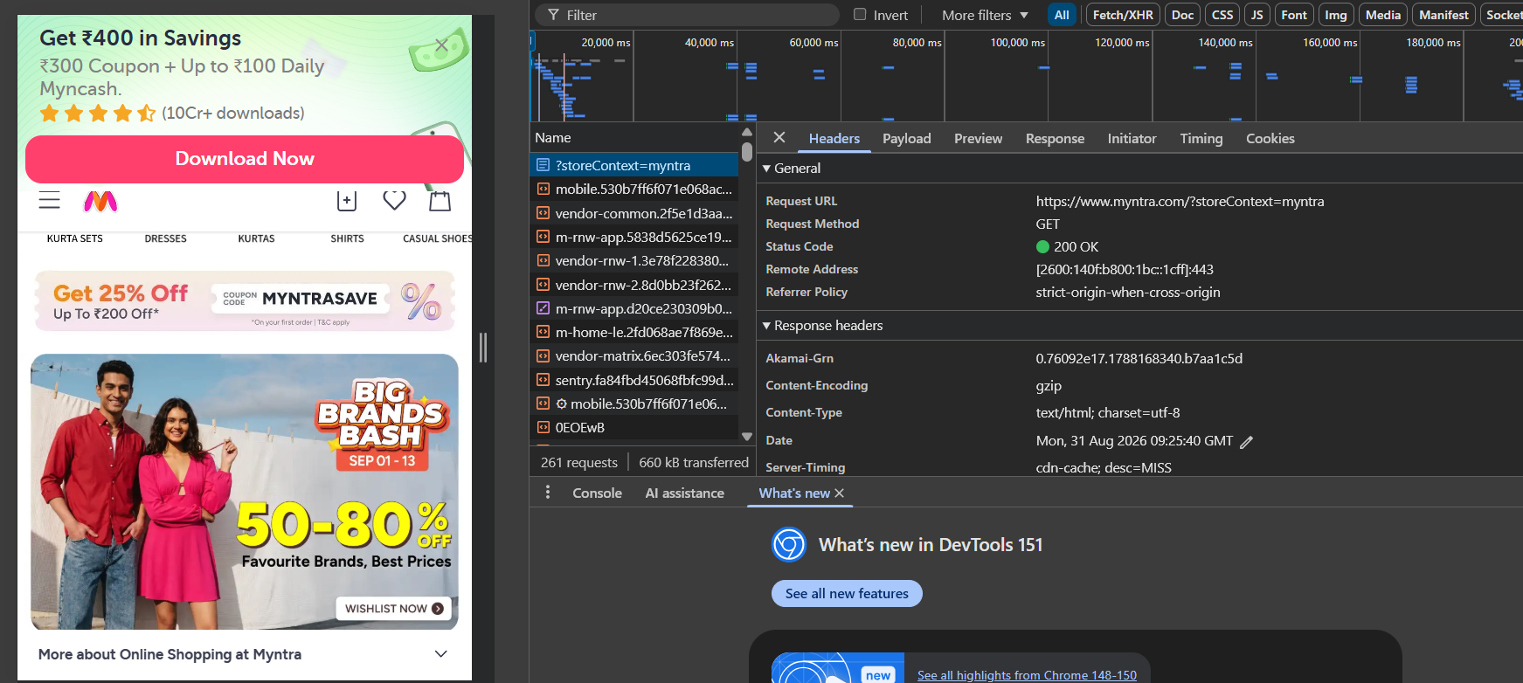
- Create a simple HTML file and set up a 301 redirect to another page using an .htaccess file or server configuration on localhost.<br><br><em><strong>Hint:</strong> Use 'Redirect 301 /oldpage.html /newpage.html' in your .htaccess if using Apache.</em>
<!DOCTYPE html>
<html>
<head>
<title>Old Page</title>
</head>
<body>
<h1>This is Old Page</h1>
<p>This page will redirect to the new page.</p>
</body>
</html>
<!DOCTYPE html>
<html>
<head>
<title> New Page </title>
</head>
<body>
<h1>Welcome to New Page</h1>
<p> You have been redirected successfully..</p>
</body>
</html>
Dono HTML files ke same folder mein .htaccess file banao aur ye line likho:
Redirect 301 /oldpage.html /newpage.html

- Simulate a redirect loop by creating two HTML files that each redirect to the other using meta refresh tags, then describe what happens in your browser and which HTTP status code (if any) you observe.
Two HTML pages were created using meta refresh tags. Page 1 redirects to Page 2, while Page 2 redirects back to Page 1, creating an infinite redirect loop. The browser eventually stops and displays an ERR_TOO_MANY_REDIRECTS error. Since meta refresh is a client-side redirect, no 301/302 HTTP status code is generated by the meta refresh itself; the HTML pages may initially return 200 OK.
- Pick any broken link from a real website (for example, a non-existent product on Flipkart) and note the exact HTTP status code shown. Explain the difference between 404 and 410 status codes in your own words.
https://seller.flipkart.com/page-not-found

Difference between 404 and 410
- 404 Not Found: The requested page cannot be found. It may have been deleted, moved, or the URL may be incorrect. It doesn't specifically say whether the page is permanently gone.
- 410 Gone: The page has been permanently removed and the server is intentionally telling search engines that it is gone.
- Sign up for a free Cloudflare account and add any personal or test domain (or use Cloudflare's playground if you don't have a domain). List three features Cloudflare provides for improving website performance or security.
Cloudflare Features:
- CDN – Improves website loading speed.
- DDoS Protection – Protects the website from malicious traffic attacks.
- SSL/TLS – Secures the website using HTTPS encryption.

